AIAC ASSIGNMENT
WEEK 6
NAME:P.KANISHKA
ROLL NO: 2403A51231

TASK 1:
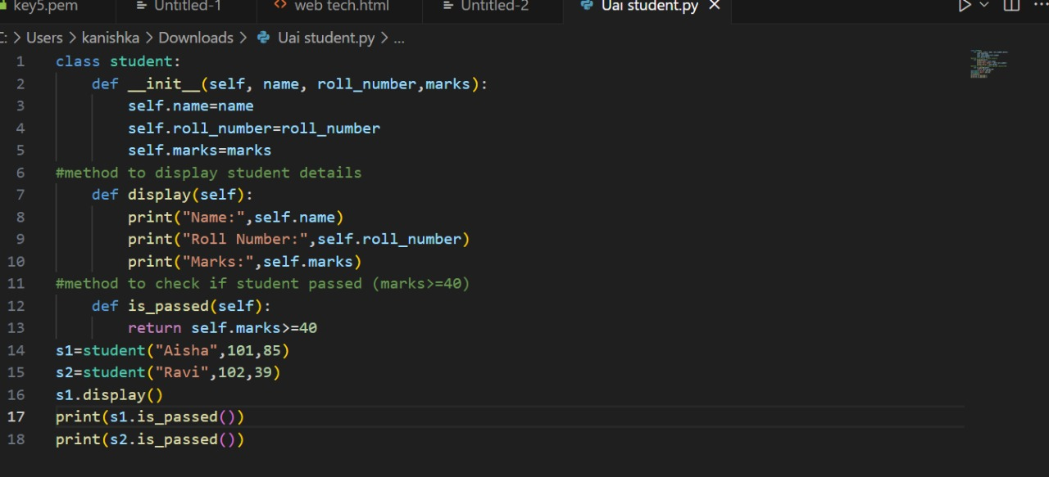

OUTPUT:

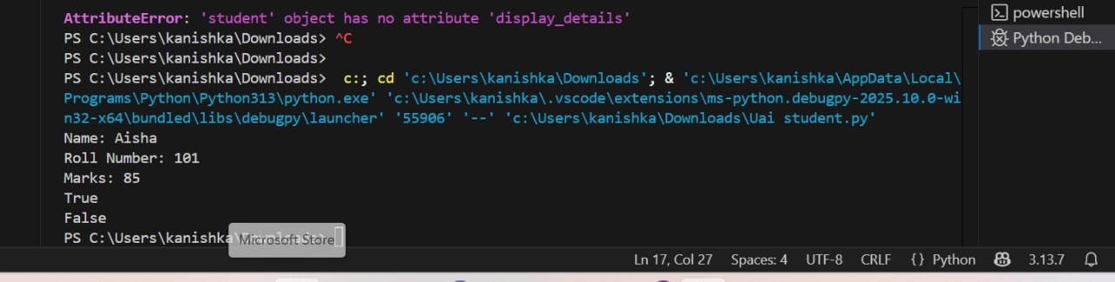

TASK 2:

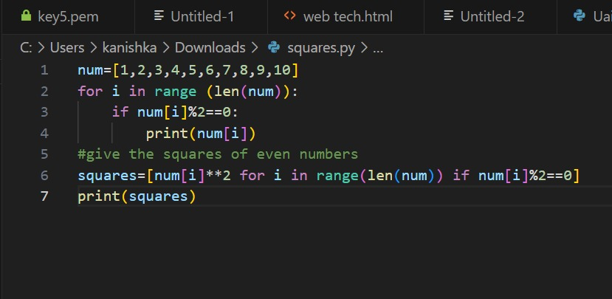

OUTPUT:

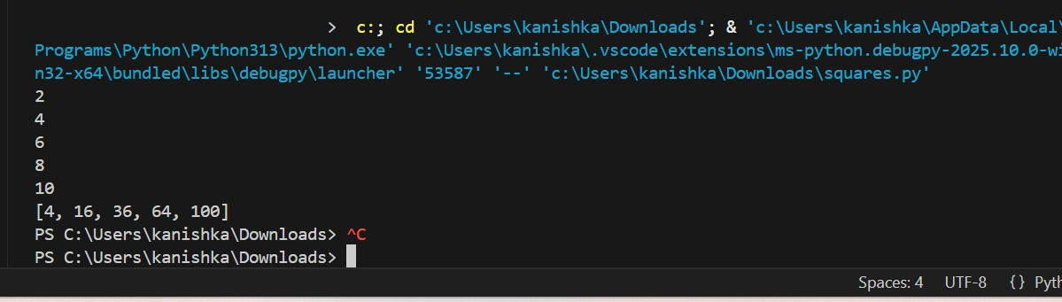

TASK 3:
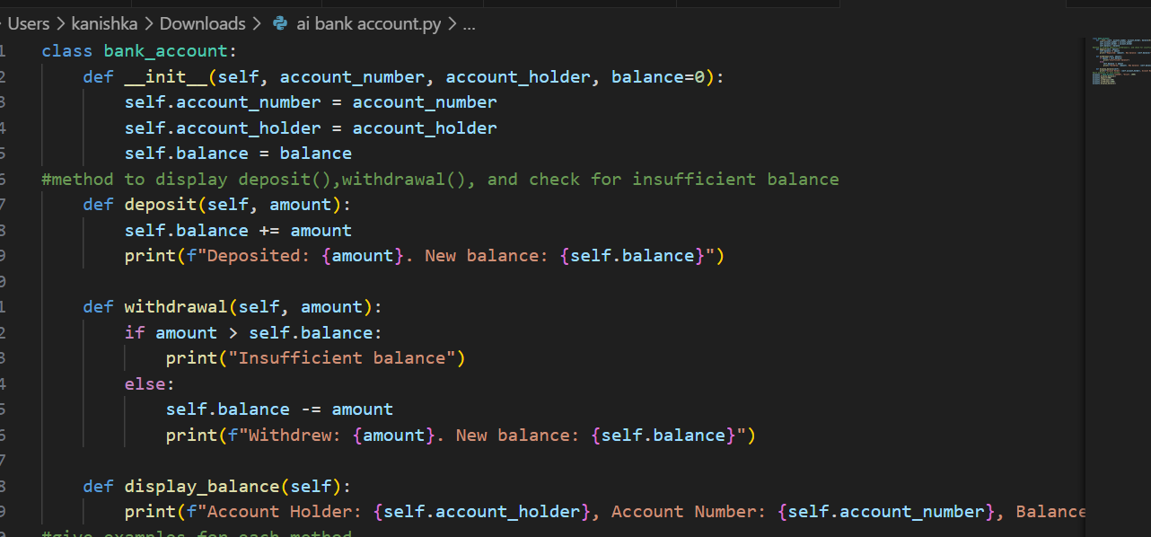

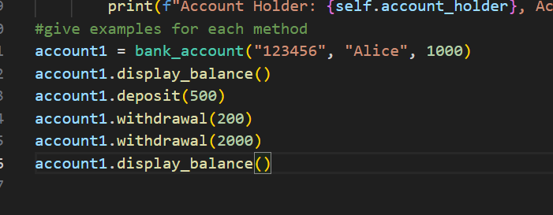

OUTPUT:
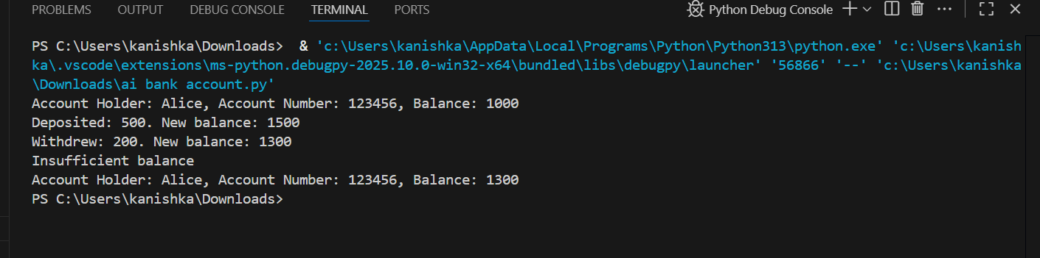
TASK 4:

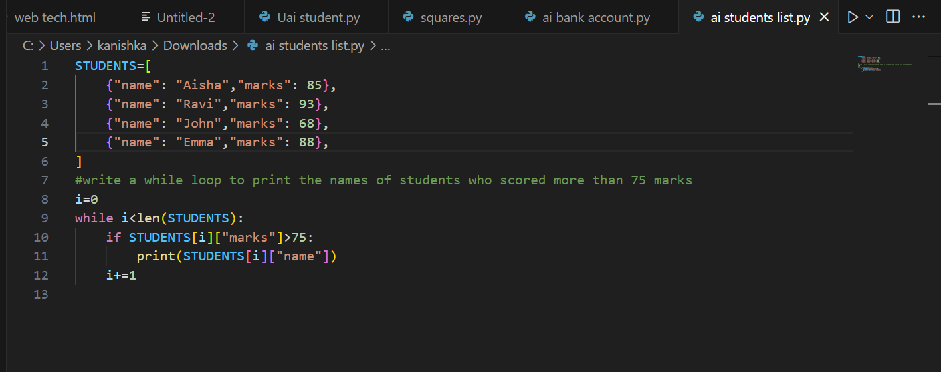

OUTPUT:
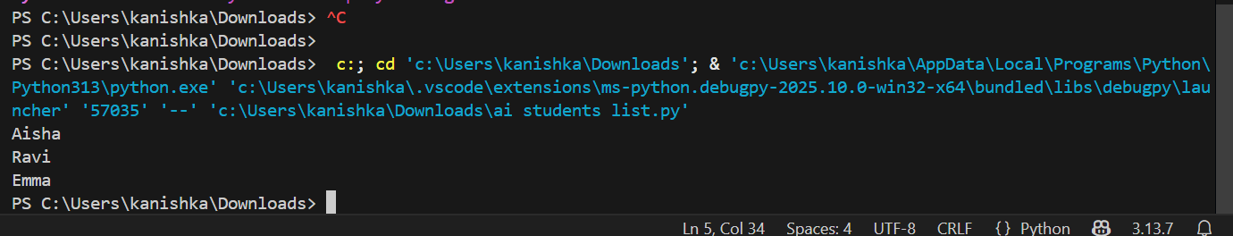

TASK 5:
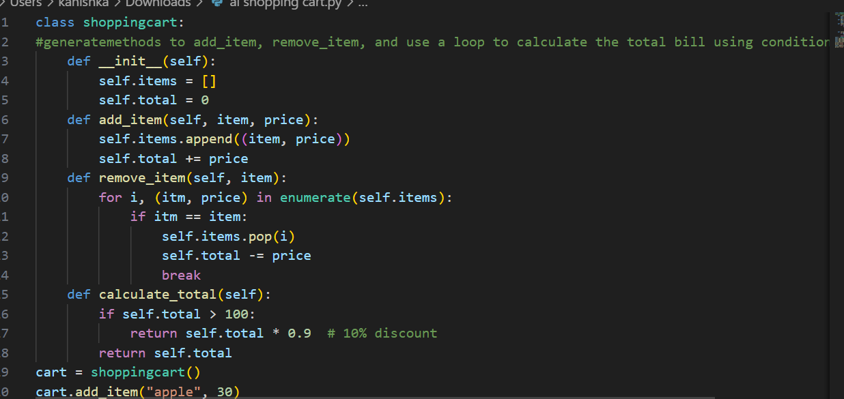
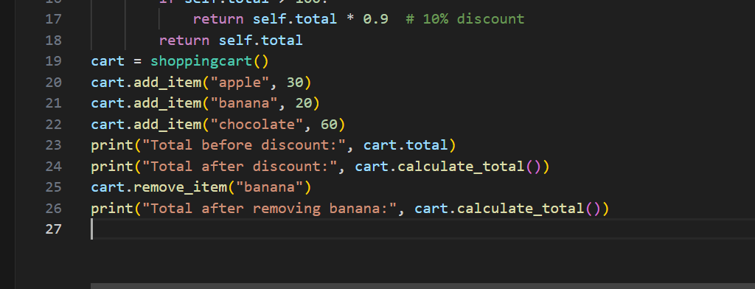

OUTPUT:

